ASSIGNMENT - 2

**Ques 1 :- Write a program to find the largest of three numbers using if-else.**

Code:

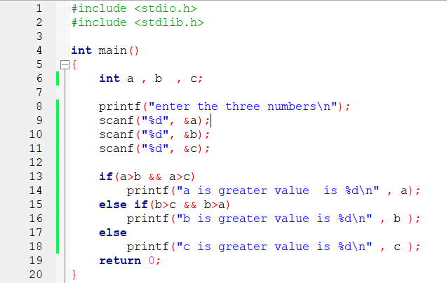

Output:

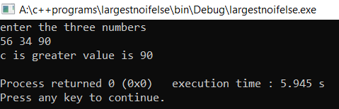

AKSHAR BISHT 1 BCA 1st YEAR 2ND SHIFT

**Ques 2 :- Write a program to print largest of three numbers using conditional operator**.

Code:

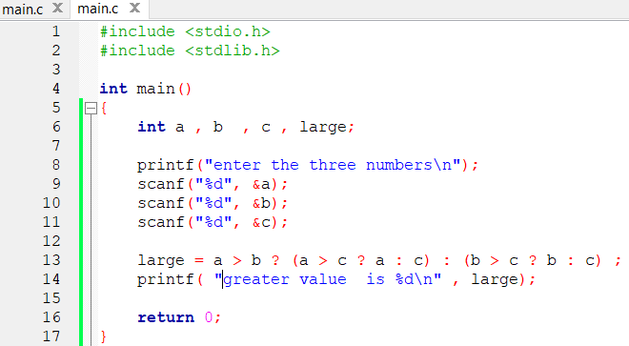

Output:

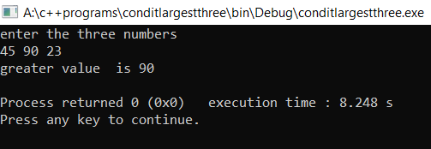

AKSHAR BISHT 2 BCA 1st YEAR 2ND SHIFT

**Ques 3 :- Write a program to calculate the roots of a quadratic equation.**

Code:

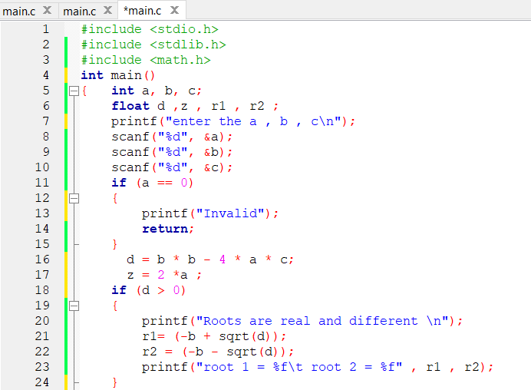

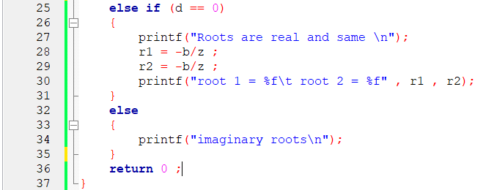

AKSHAR BISHT 3 BCA 1st YEAR 2ND SHIFT

Output:

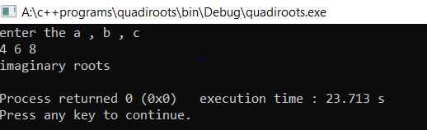

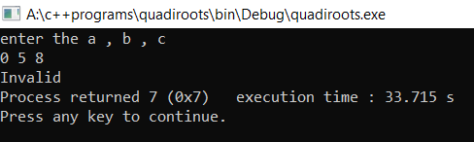

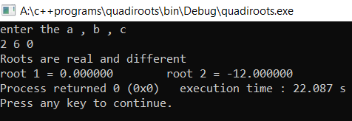

AKSHAR BISHT 4 BCA 1st YEAR 2ND SHIFT

**Ques 4 :- A department store places an order with a company for n pieces of miners, m pieces of toasters and p number of fans the cost of these items is as follows:-**

**Miners : Rs.1500/piece**

**Toasters : Rs.200/piece**

**Fan : Rs.450/piece**

**The discount allowed for various items are 5%for miners, 15% for fan and 10% for toasters. Write a program that reads m, n and p and computes the amount to be paid by the store.**

Code:

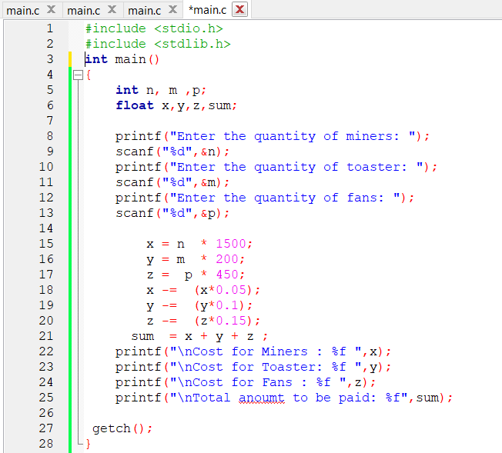

AKSHAR BISHT 5 BCA 1st YEAR 2ND SHIFT

Output:

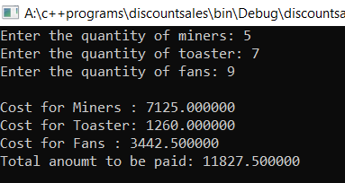

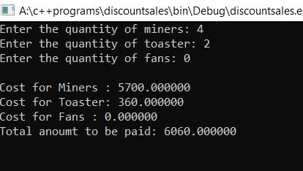

AKSHAR BISHT 6 BCA 1st YEAR 2ND SHIFT

**Ques 5 :- Write a program to determine wheather an entered character is a vowel or not.(use switch case statement)**

Code:

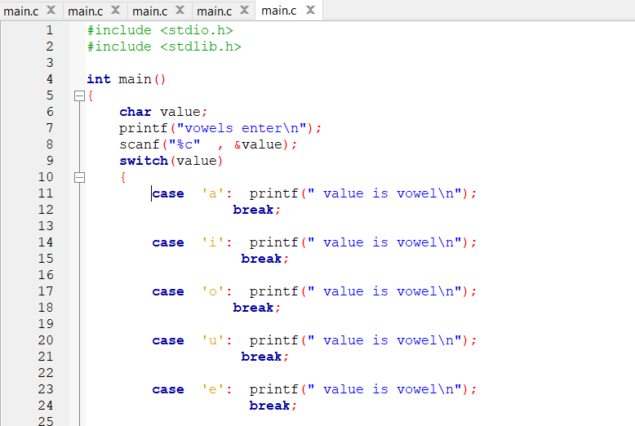

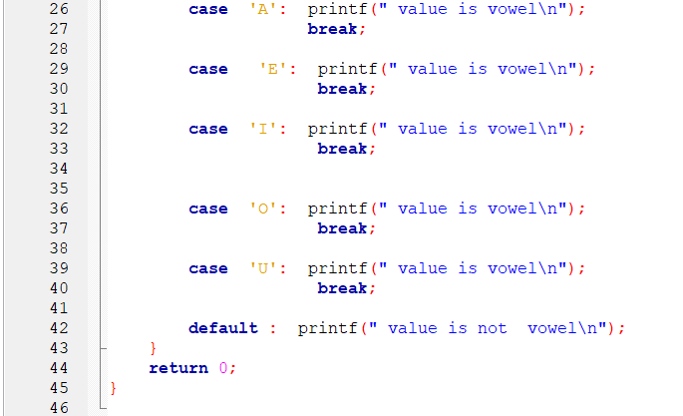

AKSHAR BISHT 7 BCA 1st YEAR 2ND SHIFT

Output:

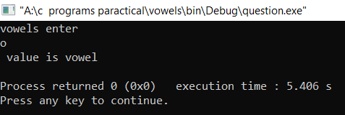

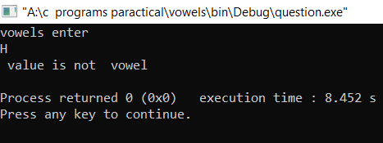

AKSHAR BISHT 8 BCA 1st YEAR 2ND SHIFT

**Ques 6:- WAP to print the following pattern?**

A . * B . 1 C. 0

**\*\* 22 12**

**\*\*\* 333 345**

**\*\*\*\* 4444**

**\*\*\*\*\* 55555**

Code:

1. 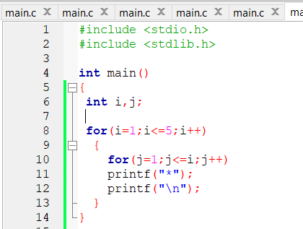

Output:

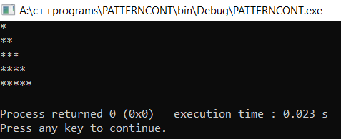

AKSHAR BISHT 9 BCA 1st YEAR 2ND SHIFT

Code:

1. 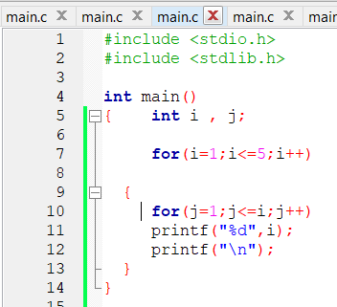

Output:

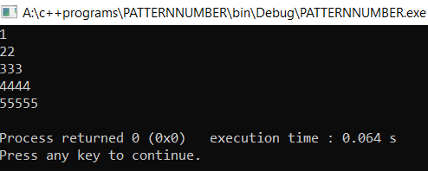

AKSHAR BISHT 10 BCA 1st YEAR 2ND SHIFT

Code:

C. 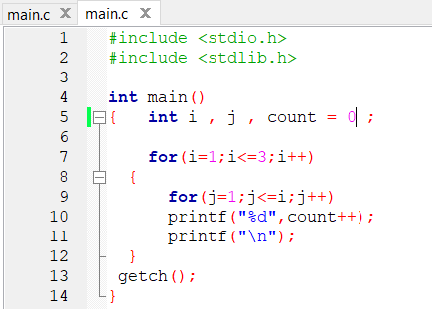

Output:

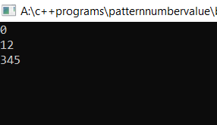

AKSHAR BISHT 11 BCA 1st YEAR 2ND SHIFT

**Ques 7:- WAP to calculate the sum of following series 1/12+1/22+……1/n2**

Code:

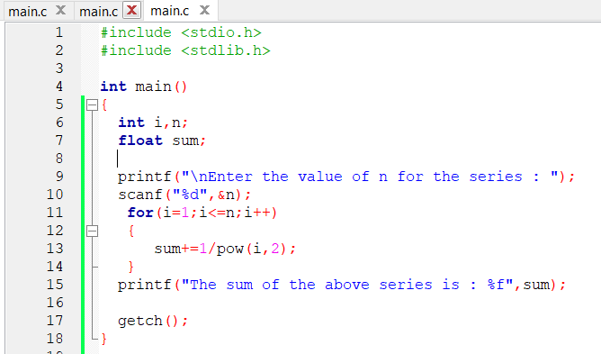

Output:

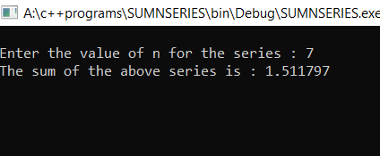

AKSHAR BISHT 12 BCA 1st YEAR 2ND SHIFT